2027
Scouting for Food

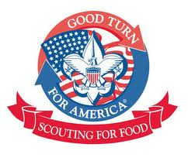

Leader’s Guide

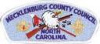

Mecklenburg County Council
Scouting America

to benefit

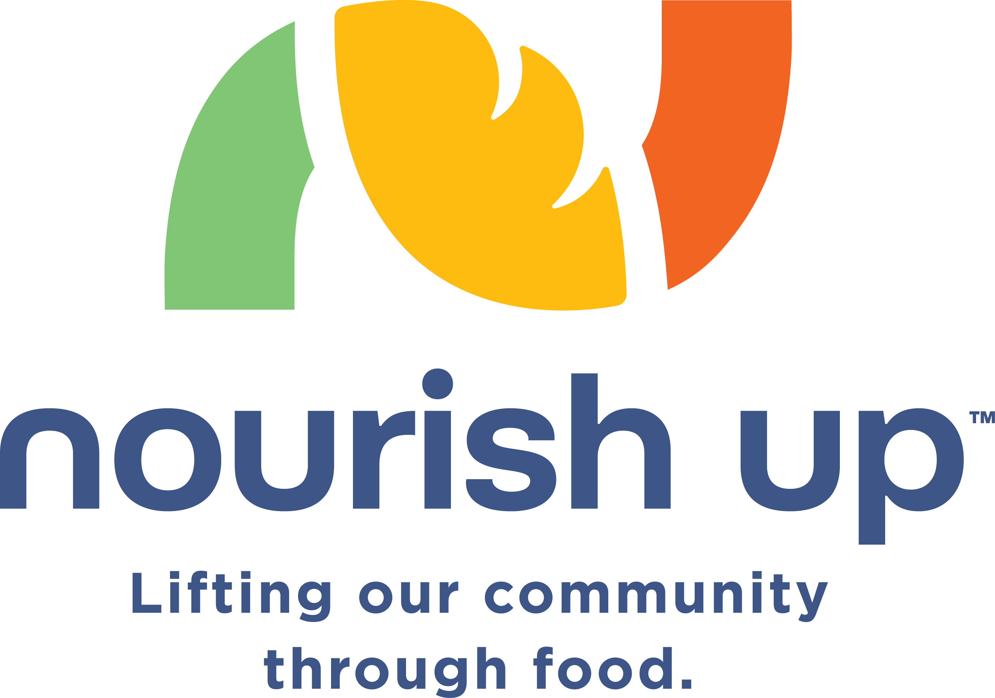
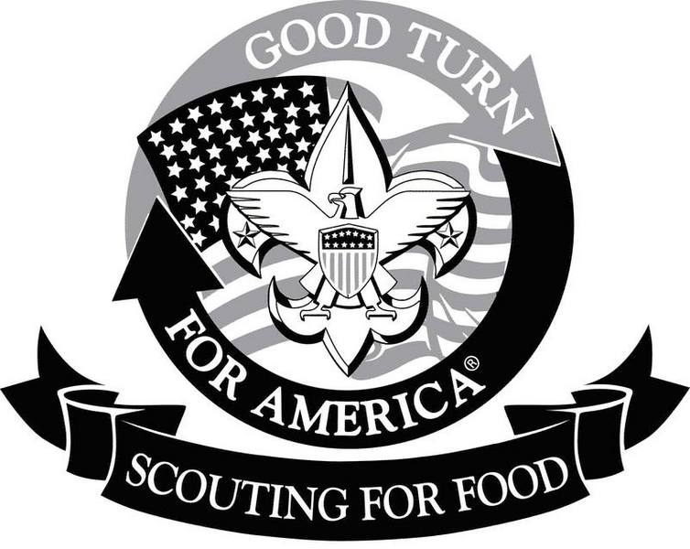
Mecklenburg County Council – Scouting America
Scouting for Food

Table of Contents

Page #

Welcome Message 3
SFF General Information 4
Important Dates 6

Quick Guide 7

Unit Leader’s Check List 8

SFF Contacts 9

Food Collection Sites 10
Publicity / Media and Other Facts 11

Resources:
Church Notices 12
Clip Art for Flyers 13
Sample Flyers 16
Scout Sunday Church Flyers 15
Thank You” door hangers 14
Getting the Word Out Through Neighborhood Facebook Pages 17
Request for Door Hangers & Unit SFF Coordinator Form 18

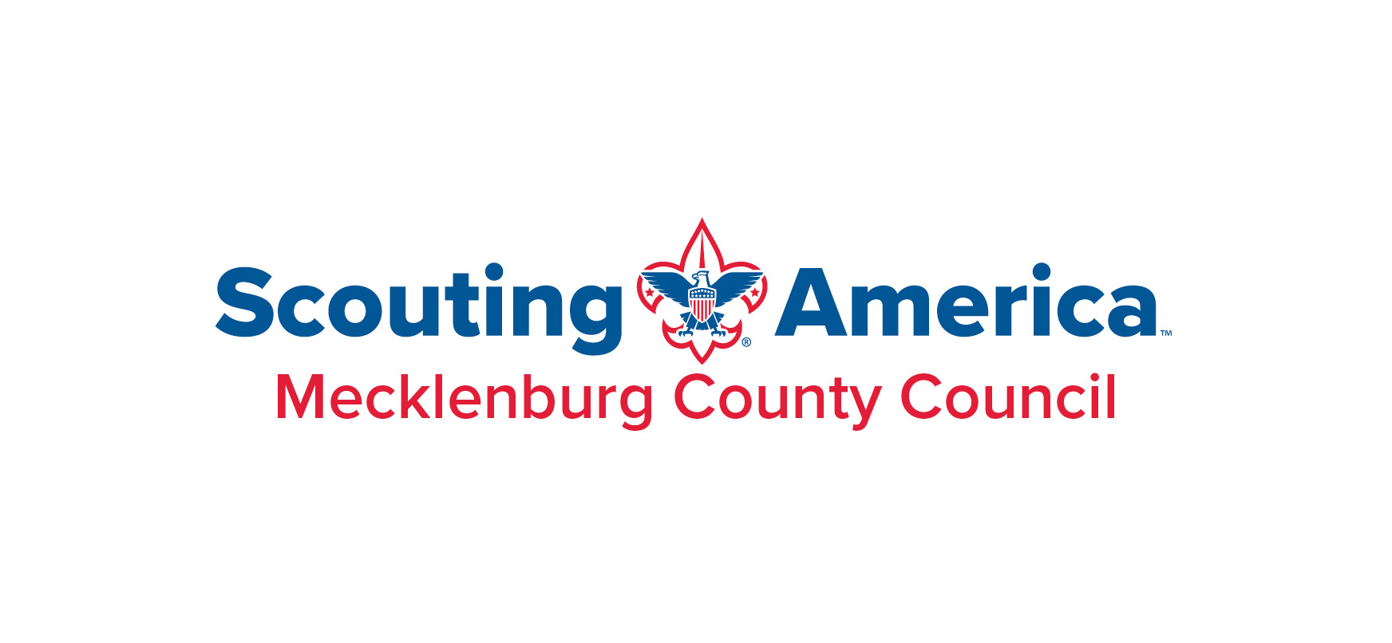

Dear Friends,

Thank you for your participation in this year’s “Scouting for Food” effort. Scouting for Food is the official “Good Turn for America” project for the Mecklenburg County Council. As an organization, Scouting America is dedicated to giving back to our local communities while teaching our youth the value of helping others.

As we begin the 2027 Scouting for Food effort, our community and council are facing several challenges. We had a difficult Scouting for Food in 2026 with the weather not cooperating while not being able to get out as many door tags as we would like. The harsh reality is our neighbors here in Mecklenburg County still need and require basic food assistance and supporting Nourish Up is the best way to provide this much needed assistance!
Our neighbors in Mecklenburg County still need our help.

Because of the weather last year, we are asking ALL units to consider taking on additional neighborhoods. This requires more time and effort, but it will also increase the amount of food we collect for our neighbors in need.

We also want to remind units we have included a large blank white area at the bottom of the door hangers. This is done so your unit and scouts can personalize the door hangers by adding a name, phone number, unit number, etc. Several units make small stickers with this information already included. Not only is this information helpful to the homeowner, it also provides a great way for each unit to market itself in your community.

There are some changes to collection sites this year. Please refer to the leader’s Guide for locations and operating hours.

Finally, please ask your scouts and drivers to not pick up home food deliveries or packages that may be on a front porch. This has happened several times in the past years. Luckily the homeowners have all handled it with grace and laughter.

Once again, we want to “Thank You” for your participation in Scouting for Food and everything you do for the youth in our community.

Yours in Scouting,
Mark Turner Brian Tenholder
Council Executive Scouting for Food Chairman
Mecklenburg County Council Mecklenburg County Council
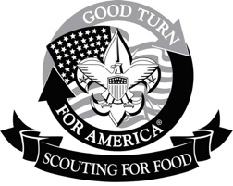
Mecklenburg County Council – Scouting America
Scouting for Food

Background

Studies indicate that more than 50 million Americans, including 17 million children go hungry at some time every month; these studies also reveal that there are more hungry people in America now than in any time in the last twenty-five years.

Hunger is a problem we can do something about by working together. Scouting for Food is a starting point. It is an example of our long-standing commitment to community service. Throughout this project Scouting America directly helps meet the needs of the hungry, while exposing its members, particularly its youth, to the highest ideals of the Scouting movement through a practical and dramatic experience in the principle of the Good Turn.

Scouting America’s role is to organize the food collection. Locally, the food collected during the “Scouting for Food” campaign is warehoused and distributed, by Nourish Up through their network of food pantries, to our neighbors in need.

History

Thanks to the hard work of many scouts, scouters, and scouting families, the generosity of our friends and neighbors, these are the food totals from recent years: Totals are equivalent of pounds collected and donations at $1 = 4 pounds.

2026 226,556 lbs.
2025 185,000 lbs.
2024 180,000 lbs.
2023 216,985 lbs.
2022 202,768 lbs.
2021 346,000 lbs.
2020 278,859 lbs.
2019 255,317 lbs.

2027 Goal

Our goals in 2027 are:
1: To collect enough food for Nourish Up to serve all residents who need their assistance
2: To have every Troop, Pack, Venturing Crew, and Explorer Post in Mecklenburg County Council actively participate in Scouting for Food.

Nourish Up (formerly Loaves & Fishes/Friendship Trays

All the food collected will be distributed by Nourish Up through its network of food pantries located throughout Mecklenburg County. Nourish Up provides a week’s worth of nutritious groceries and home delivered meals to families and individuals in need. For more about Nourish Up please visit: www.nourishup.org.

Cash and Online Contributions

Although the contribution of food is preferred, cash contributions are also accepted and will be used to buy needed food. Each dollar equates to 4 lbs. of food. Checks can be written to “Scouting America-Scouting for Food” and turned in to the Scouting for Food collection site coordinator. Online “text” donations are also encouraged at text Scout4Food to 50155.

Assigned Areas

Each unit is asked to sign up for an assigned area/neighborhoods. Units with overlapping neighborhoods are asked to decide/agree ahead of time which neighborhoods they will cover. If you have any questions about your assigned area, please contact your District Scouting for Food Coordinator.

Service to Others

Scouting for Food is rooted in the very foundation of the Scouting movement. Through initiative and hard work, Scouting America has developed a framework that helps thousands of our neighbors in need. The Scouting for Food Campaign will continue to bring Scout units closer to their neighborhoods, Chartered Organizations, and community by focusing on this stewardship project aimed at addressing the problems of hunger in the communities in which we live and work.



Mecklenburg County Council – Scouting America
Scouting for Food
Important Dates

- December Roundtables – Units are asked to take the same collection area(s) as 2026 and to consider expanding your coverage area to under-served parts of Mecklenburg County. District SFF coordinators have last year’s maps with assigned areas. If you did not participate in 2026 please see your district’s SFF coordinator and ask how you can get a territory assigned.

- Before January Roundtable - Estimate the number of “door hangers” your unit will need for your collection area.

- January Roundtable - Pick up the SFF “door hangers” your unit will need. We will have reps at all Roundtable meeting locations with “door hangers”. Additional “door hangers” will be available at the Scout office, Huntersville UMC and the Nourish Up office.

- Early January- Announcements – Ask your charter organization as soon as possible to place announcements in their January newsletters and/or bulletins. Ask your clergy to include Scouting for Food in their pulpit announcements. As soon as you can, find out the deadline and put it in your calendar.

- Week of January 25th - Neighborhood “door hanger” distribution - Please distribute “door hangers” to your assigned neighborhoods (five to seven days before the Scouting for Food Pick up day).

- Saturday, February 6th – Scouting for Food 2027 – All units collect food from your assigned neighborhoods and deliver to one of the Scouting for Food (SFF) collection sites.

- If your unit is participating in church collections (in addition to your unit(s) neighborhood collections) here are other important dates:

Sunday, Jan 31st - Ask members of your congregation to bring food the following week.

February 7th (Scout Sunday) - Gather the “congregational food donations” and take to a designated SFF Sunday collection site.

Mecklenburg County Council – Scouting America
Scouting for Food

Quick Guide

Who: Scouts, leaders, and parents of Mecklenburg County Council Packs, Troops, Venture Crews, and Explorer Posts, and members of Catawba Lodge Order of the Arrow.

What: Scouting for Food is the largest single-day food collection event in Mecklenburg County. It is the number one council–wide “Good Turn for America” service project. On one day thousands of Scouts go door to door collecting non-perishable food items for our neighbors in need.

In 2026, Mecklenburg County Council Packs, Troops and Venture Crews, in cooperation with Catawba Lodge Order of the Arrow, collected and sorted approx. 226,000 lbs. of food.

When: Beginning January 25 th, 2027, Mecklenburg County Council units will distribute SFF “door hangers” asking our neighbors to participate.

On Saturday, Feb 6th units will go door–to-door to collect bags and boxes filled with non-perishable food.

On Sunday January 31st units may collect donated food at local churches, if they are meeting in person.

Where: Mecklenburg County and your unit’s service area.

Why: Since BSA’s inception in 1910, members have learned to live the principles of the Scout Oath and Law through community services and helping other people at all times. With that in mind, this is an ideal time to help Nourish Up stock food pantries shelves.

All the food collected will be distributed through one of Nourish Up’s food pantries located in Mecklenburg County where it goes directly to individuals and families in need.

Mecklenburg County Council – Scouting America

Unit Leader Check List

- Speak with your District SFF Coordinator and confirm your collection area.

- Determine how many scouts will participate and how many adults will be available to drive when distributing “door hangers”.

- Determine how many homes are within your assigned collection area.

- Determine number of “door hangers” needed and share with your District Coordinator. The number should be the similar to 2026.

- Create additional marketing tools as needed.

- Distribute “door hangers” and delivery instructions to scouts and parents before event.

- Assemble all scouts and adults to receive final instructions before distributing “door hangers” and collecting food.

- All scouts wear “Class A” uniforms when distributing “door hangers” and collecting food.

- Scouts stay in buddy teams. Please note, no scout should be alone and none are to ride in the back of pickup trucks.

- Begin distribution and collection after 9:00am, not earlier.

- Hang the “door hangers” on front door or place it on the front porch - do not knock, (but if the resident is outside or greets you, explain the program). Please do not cut across yards – use sidewalks or driveways – DO NOT PUT “DOOR HANGERS” ON MAILBOXES (NEWSPAPER TUBES ARE O.K.)

- On collection day, only collect visible bags - do not knock or ask for bags.

- IMPORTANT - have a 'Clean Up' team re-visit your assigned area at least one time in the early afternoon in order to gather “missed or late” bags.

- New units, please speak with your District SFF Coordinator for available neighborhoods.

Mecklenburg County Council – Scouting America
Scouting for Food

Contacts

Mecklenburg County Council Contacts:

Brian Tenholder Council Chairman (704) 287-8937 bten1189@yahoo.com

Andrew Derderian co-chair Council SFF Media contact
(704) 615-1534 andrew@charmeckgroup.com

Bill Kalbas – co-chair Council SFF Media contact
(813) 493-1512 w.kalbas@gmail.com

Alan Keiger Council Staff Advisor
(704) 342-9325 alan.keiger@scouting.org

District Coordinators

Apache District Brian Hooper behooper@gmail.com

Etowah District Michael Hillesheim mbhilles@gmail.com

Hornet’s Nest District David McKenzie davidcmckenzie@gmail.com

Nourish Up Contacts

Martha Cochrane, Nourish Up – Volunteer and Food Drive Coordinator (704) 523-4333 mcochrane@nourishup.org

Courtney Oates, Nourish Up – Marketing and Events Director
(704) 523-4333 office, (704) 763-8796 cell coates@nourishup.org

Mecklenburg County Council – Scouting America
Scouting for Food

Designated Food Collection Sites

Please deliver food to the designated collection sites. Collection sites will be open from 10:00 am to 3:00 pm on Saturday (February 6th) and a limited number of sites on Sunday (February 7th) from 12:30 pm to 2:30 pm.

Ada Jenkins Center (Saturday only)
212 Gamble, Davidson, NC 28036

Arboretum Shopping Center (Saturday and Sunday)
Pineville Mathews Road and Providence Road

Huntersville United Methodist Church (Saturday and Sunday)
14005 Stumptown Road, Huntersville, NC 28078

Philadelphia Presbyterian Church (Saturday only)
11501 Bain School Road, Mint Hill NC

Sharon Presbyterian Church (Saturday and Sunday)
5201 Sharon Road, Charlotte, NC 28210

Good Shepherd Church (Saturday only)
13110 Moss Road, Charlotte, NC 28273

Sardis Presbyterian Church (Saturday only)
6100 Sardis Road, Charlotte, NC 28270

Mecklenburg County Council – Scouting America
Scouting for Food

Publicity

We ask that all publicity be coordinated by our marketing committee and Nourish Up. Please let us know of any great "press" opportunities you may have, or if you have contacted the press, please let us know.

Scouting for Food Marketing and Press contacts:

Andrew Derdarian – co-chair Mecklenburg County Council Scouting America
(704) 615-1534 andrew@charmeckgroup.com

Bill Kalbas – co-chair Mecklenburg County Council Scouting America
(813) 493-1512 w.kalbas@gmail.com

Courtney Oates – Nourish Up Marketing and Media Relations
(704) 523-4333 office, (704) 763-8796 cell coates@nourishup.org

Food Sorting
We ask that units drop off collected food at designated sites. Catawba Lodge members and volunteers will load the food directly into the trailers. The un-sorted food will be transported to the Nourish Up warehouse where it will be weighed and volunteers will sort food (at a later date).

Nourish Up now prefers this collection method because it provides volunteer opportunities for Scout units and community/business groups. To help sort food, please contact Nourish Up directly and arrange for a time to work in the warehouse. Group size and age restrictions are in effect. Please contact Martha at Nourish Up directly for details: mcochrane@nourishup.org or (704) 523-4333.

TEXT TO GIVE

Participants may choose to give money directly to Nourish Up. This is a great option for those concerned about Covid exposure. Information for how to “TEXT TO GIVE” is included on the “door hanger”. Text Scout4Food to 50155

Mecklenburg County Council – Scouting America
Scouting for Food

Church Notices

Scout Sunday is February 7, 2027
Please provide information to your sponsoring congregation in time to be included in:
- Weekly and monthly Newsletters and e-mail blasts during January and February.
- E-blast announcements
- Websites
- Sunday Bulletins

Sample Announcement:

Scouting for Food – Scout Sunday, February 7th

Pack/Troop xx is participating in Scouting for Food to support Nourish Up. We will be collecting food on Sunday, February 7th. All food collected will go directly to feed our neighbors in need through the Nourish Up network of food pantries located throughout Mecklenburg County.

Priority food needs include canned fruit (especially no sugar added), canned meats, canned pastas, cereal and low or no sodium canned vegetables.

Please be generous and help Scouts do a good turn by feeding the hungry in our community!

Mecklenburg County Council – Scouting America
Scouting for Food

Flyers

(These are flyers used in previous years that were attached to bags. You may find them helpful with your marketing efforts, or you may also make your unit-specific flyers.)

- Flyers:
- Preprinted flyers for Scouting for Food are available electronically.
- On the Scout Sunday flyers, be sure to add your Church name and Pack and/or Troop number in the spaces marked as (XX).
- To create your own flyers:
It is always very effective when troops and packs create their own personalized flyers. Be sure that Nourish Up is listed as the recipient and it is helpful to remind people not to include glass items.

NOTE: It is our suggestion that the Scouts do not put their full names on the flyers. Names are not really required, but if you use names, we suggest only the first initial and last name (for youth safety). Do not list the Scouts home address on the flyer – only generic information such as their Troop or Pack number or where their unit meets. We want to maintain “Safe Scouting”.

Remember – Nourish Up has a suggested priority needs list. The items include canned fruit (especially no sugar added), canned meats, canned pastas, cereal and low or no sodium canned vegetables.

Clip Art for flyers.
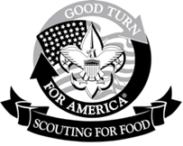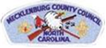

Scouting for Food - February 6, 2027

Mecklenburg County Council – Scouting America


Scouting America – “Good Turn for America” - Help us support our neighbors in need!
On Saturday, February 6th, Scouts, Cub Scouts, Venture Crews, and Explorers will be participating in the annual Scouting for Food drive to support Nourish Up. We will be going through the neighborhood collecting non-perishable food items beginning at 9:00 am. In greatest demand are canned fruit (especially no sugar added), canned meats, canned pastas, cereal and low or no sodium canned vegetables. (We cannot collect glass containers.) Please donate to this food drive and place your food donations in a bag or box. Please place the bag on your front porch or by your mailbox by 9:00am Saturday, February 6th.
Thank you for your generosity and support!

Scouting for Food
on “Scout Sunday” - February 7, 2027

Please help us support our neighbors in need
On Scout Sunday, February 7th, Scouts and Cub Scouts from __________________ Church, Pack/Troop_____ will be participating in the “Scout Sunday” portion of our annual Scouting for Food drive to support Nourish Up. Our Scouts will be at the Sunday services, February 8th, collecting non-perishable food items. In greatest demand are canned fruit (especially no sugar added), canned meats, canned pastas, cereal and low or no sodium canned vegetables. We cannot collect glass containers. Please help us help our neighbors in need by donating to the annual Scouting for Food drive. Place your donation in a bag or box, and bring it with you to Church on Scout Sunday!
Thank you for your generosity and support in helping the Scouts.

Mecklenburg County Council Mecklenburg County Council
Scouting America Scouting America
Scouting for Food Scouting for Food

Thank you Thank you
for your generosity for your generosity
and support! and support!

All of the food collected will All of the food collected will be distributed from one of be distributed from one of
the Nourish Up the Nourish Up
food pantries where it goes to food pantries where it goes to
feed individuals and families feed individuals and families
in need. in need.

________________________________________________________________________________

Mecklenburg County Council
Scouting America
Scouting for Food
“Thank You” Door Hangers
These can be left behind at
any home which has donated
Thank you food to the Scouting for Food
for your generosity campaign.
and support!
All of the food collected will Suggestion:
be distributed from one of
the Nourish Up Punch a hole in the top corner,
food pantries where it goes to put yarn or string through the hole
feed individuals and families and hang on the door handle. in need.

Getting the Word Out – We Need Your Help!

Social Media is one of the best ways to get the word out that Scouting for Food is coming to your neighborhood.

So many neighborhoods have a dedicated neighborhood Instagram and Facebook pages as well as Next Door pages, making it easy to alert neighbors that Scouts will be coming to drop off door hangers with information about Scouting for Food and then reminding them to put their bags out for pick up by
9am Scouting for Food Saturday.

If you are collecting in your neighborhood, please take a minute to post on your own neighborhood pages and ask the parents in in your units to do the same for their neighborhoods. Adding a photo of the door hanger, scouts from your unit putting them out, or a full bag out on the porch ready for pick up would all be a great way to catch neighbors’ attention.

Then feel free to add something along the lines of:
It’s time for Scouting for Food! Be on the lookout for a door hanger with information about Scouting for Food to arrive on your doorstep this week. Scouts from Troop xx will begin dropping them off in the neighborhood starting Monday. Simply fill a bag or box with nonperishable food items such as canned fruit (especially no sugar added), canned meats, canned pastas, cereal and low or no sodium canned vegetables and leave out for pick up by 9 am Saturday, February 6. All food donated will go to feed hungry neighbors in need through Nourish Up!

.
Mecklenburg County Council – Scouting America
Scouting for Food

Request for Door Hangers & Unit Coordinator Contact Form

Number of Scouting for Food “Door Hangers” needed for distribution ________.

Check one:
  □ Pack
  □ Troop #___________ District _________________________
  □ Crew
  □ Team
  □ Post

Unit “Scouting for Food” Coordinator: _______________________________

Address: ______________________________________________________

Email: ________________________________________________________

Phone: (H) ________________________(C)__________________________

NOTE:
“DOOR HANGERS” WILL BE DISTRIBUTED AT YOUR JANUARY ROUNDTABLE

Additional “Door Hangers” will be available at the Scout Office and Huntersville UMC
Or
Nourish Up Warehouse
901 Carrier Dr. – Charlotte NC, 28216

ALL UNITS: PLEASE SHARE THE INFORMATION ON THIS FORM WITH YOUR SFF DISTRICT COORDINATOR

