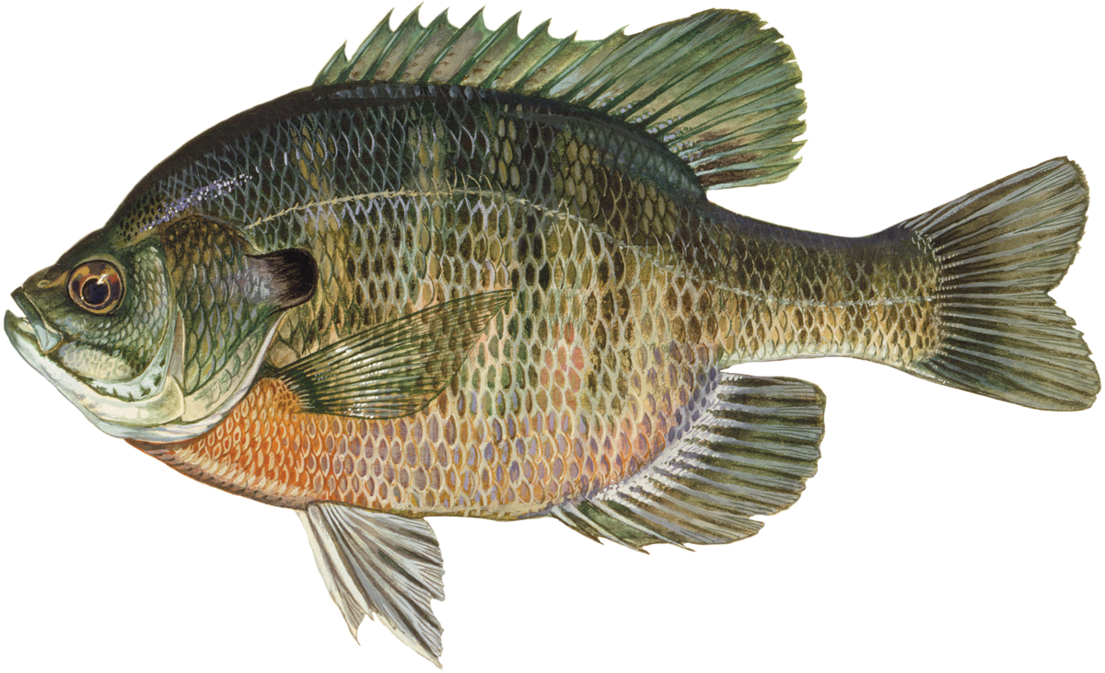

Belk Scout Camp
2022 Fishing Guide

Introduction
Welcome to Belk Scout Camp. Lake B.B. Parker is a seven acre carefully managed pond that offers some great fishing opportunities to Scouts, Scouters, parents, and friends.

Places to Fish at Belk Scout Camp
You can fish anywhere, except in the “No Fishing Area” and around the aerator.

Catch and Release
Unless instructed otherwise by MCC Fishing or the Camp Ranger -All fishing is Catch and Release.

Protect our fish.
Protect the fish’s slime covering. Wet your hands before touching the fish.

What kinds of fish live in our lake? Hybrid Bluegill, Redear Sunfish, Large Mouth Bass, Copper Nose Minnows and Grass Carp If you want to see what they look like visit .NC Widlife Fish Species

Before you fish
- If you are new to fishing, get some basic instruction before you start fishing.
- Learn a few basic knots, how to rig a line, and learn how to cast.
Also learn about the types of fish that live in the lake, and the animals that live around the lake.

Safety First
- Wear a hat, preferably broad-brimmed.
- Wear eye protection; sunglasses or safety glasses.
- Bring your personal First Aid Kit and filled water bottle.
- Use the buddy system. Fishing with a friend is a lot more fun.
- Look around you before you cast. If you have someone near you, find another place to stand.
- When appropriate, use sunscreen and bug spray.

Hooks
- We suggest long shank barbless hooks. Size 6 or 8 work for panfish.
- Use circle or barbless hooks or smash down the barbs on all hooks.
- For safety reasons –we recommend No Treble Hooks!

Bait
- Red worms, night crawlers, crickets, or corn.
- Do not bring shiners or other bait fish.
- Perry’s Market is one of our supporters, and a great source of bait, tackle, and information. The store is located at 6727 Wilgrove Mint Hill Road, Charlotte 28227

Other tips
- Don’t leave your fishing rod in the water with the line unattended.
- Leave the lake area cleaner than you found it.

Loaner tackle
We have some loaner cane poles, rods and tackle. They are available through the Campmaster’s office. If the rod or reel breaks or stops working, tell the Campmaster. If it can be fixed, he or she will mark it with orange tape and set it aside for repair.

Tell us about your catch
- Keep track of what you caught and report your catch to your adult leader.
- Scoutmasters – Please send the information and photos to mccfishing415@g.mail.com

FISH ON!!!

